Table of Contents
Conjoint Analysis 1
Interactions in Machine Learning 1
Without Interaction 1
With Interaction 1
Polynomial Linear Regression 7
Disadvantages of Polynomial Regression 8
How Polynomial Linear Regression Works 8

Conjoint Analysis
Conjoint Analysis is a market research technique used to understand how consumers value different features of a product or service.

Conjoint analysis is usually a survey-based statistical technique which is used to determine how people value different features of a product or service. In a survey, respondents are presented with a set of hypothetical products or scenarios that vary in their attributes (e.g., price, brand, features). They are then asked to rank, choose, or rate their preferences among these options. By analyzing these responses, conjoint analysis helps identify the most influential attributes and their relative importance for product design.

Interactions in Machine Learning
In machine learning, an interaction occurs when the effect of one feature on the target variable depends on the value of another feature. This means that the relationship between a feature and the outcome is not independent but influenced by another feature.

Imagine you're building a machine learning model to predict customer satisfaction with mobile phones. Two key features in your dataset are:

- Battery Life (hours)
- Screen Size (inches)

Without Interaction
If we assume battery life and screen size affect satisfaction independently, the model might learn that longer battery life leads to higher satisfaction and a larger screen leads to higher satisfaction. However, this view ignores how these two factors might work together.

With Interaction
A larger screen consumes more power, which can lead to shorter battery life. If a phone has a large screen but poor battery life, satisfaction might decrease, even though each feature separately suggests higher satisfaction. If a phone has a small screen and long battery life, some users may be dissatisfied because they value display size more than battery longevity.

By adding an interaction term (Battery Life × Screen Size) in the model, it can learn that satisfaction depends not just on the individual features but on their combined effect.

Example 1: Conjoint Analysis
This example shows the analysis for a single person’s response to a survey about mobile phones where they are asked to rank their preferences between 1 for lowest and 10 for highest. Note that in conjoint analysis, features are called attributes and sub-options for each attribute are called levels.

Note that the part-worth utilities (customer satisfaction) for each level are determined using the coefficients of an OLS summary.

Plots of part-worth utility and feature importance also help to understand the interactions.
Higher price offers the most utility. The consumer perceives better quality with the higher price.

Screen size of 5.5 inches and battery life of 15 hours offer the next most utility.
The conjoint analysis reveals price is the most important feature of the product offering.
In interaction plots, really long error bars indicate consumer indifference.

5.5-inch screens are general rated higher for all battery lives.

Higher price with 5.5-inch screen or 6.1-inch screen is preferred the most.

Preference for screen size at lower prices is relatively stable for all prices which indicates consumer indifference about screen size for less expensive phones.
There is a willingness to pay a higher price for more battery life.

This code generates all possible attribute combinations for one person.

import pandas as pd
import numpy as np
import itertools
import statsmodels.api as sm
import matplotlib.pyplot as plt
import seaborn as sns

# Step 1: Define product attributes and levels
attributes = {
"Screen Size": ["5.5 inches", "6.1 inches", "6.7 inches"],
"Battery Life": ["10 hours", "15 hours", "20 hours"],
"Price": ["$599", "$799", "$999"]
}

# Step 2: Generate all possible product profiles (Full Factorial Design)
product_profiles = list(itertools.product(*attributes.values()))

# Convert to DataFrame
df_profiles = pd.DataFrame(product_profiles, columns=attributes.keys())

# Simulated Step 3: Generate user ratings (1-10 scale) - Replace with real survey data
np.random.seed(42) # Ensuring reproducibility
df_profiles["User Rating"] = np.random.randint(1, 11, size=len(df_profiles))

# Step 4: Encode categorical attributes into numerical values
df_encoded = pd.get_dummies(df_profiles, columns=attributes.keys(), dtype=int)

# Separate features (X) and target variable (Y)
X = df_encoded.drop(columns=["User Rating"])
y = df_profiles["User Rating"]

# Add constant for intercept
X = sm.add_constant(X)

# Step 5: Perform Regression Analysis (OLS) to estimate part-worth utilities
model = sm.OLS(y, X).fit()
print(model.summary())

# Step 6: Compute Attribute Importance
part_worths = model.params.drop("const").abs() # Get absolute values of coefficients
importances = part_worths.groupby(lambda x: x.split("_")[0]).sum()
importances = (importances / importances.sum()) * 100 # Normalize to 100%

# Step 7: Visualizing Attribute Importance
plt.figure(figsize=(8, 5))
importances.sort_values().plot(kind="barh", color="skyblue", edgecolor="black")
plt.xlabel("Importance (%)")
plt.ylabel("Attributes")
plt.title("Attribute Importance in Customer Preferences")
plt.grid(axis="x", linestyle="--", alpha=0.7)
plt.show()

# Extract part-worth utilities (Regression Coefficients)
part_worths = model.params.drop("const")

# Convert to DataFrame for plotting
part_worth_df = part_worths.to_frame(name="Utility")
part_worth_df.index = part_worth_df.index.str.replace("_", " ") # Improve readability
part_worth_df.sort_values("Utility", ascending=True, inplace=True)

# Plot part-worth utilities
plt.figure(figsize=(10, 5))
part_worth_df.plot(kind="barh", legend=False, color="coral", edgecolor="black")
plt.xlabel("Utility Score")
plt.ylabel("Feature Levels")
plt.title("Part-Worth Utilities for Feature Levels")
plt.grid(axis="x", linestyle="--", alpha=0.7)
plt.tight_layout()
plt.show()

# Step 8: Create Interaction Plots for All Attribute Pairs
attribute_list = list(attributes.keys())

for i in range(len(attribute_list)):
for j in range(i + 1, len(attribute_list)):
attr1 = attribute_list[i]
attr2 = attribute_list[j]

plt.figure(figsize=(8, 5))
sns.pointplot(data=df_profiles, x=attr1, y="User Rating", hue=attr2,
palette="coolwarm", dodge=True)
plt.xlabel(attr1)
plt.ylabel("Average User Rating")
plt.title(f"Interaction Between {attr1} & {attr2}")
plt.legend(title=attr2)
plt.grid(axis="y", linestyle="--", alpha=0.7)
plt.show()

Exercise 1 (10 marks)
Modify Example 1 so it becomes a multi-person survey. To do this, replace the highlighted code with this code:

# Step 3: Simulate Multiple User Ratings per Product Profile
num_users = 50 # Number of users in the survey
df_expanded = pd.DataFrame()

np.random.seed(42) # Ensuring reproducibility

for i in range(num_users):
temp_df = df_profiles.copy()
temp_df["User ID"] = i + 1 # Assigning a unique user ID
temp_df["User Rating"] = np.random.randint(1, 11, size=len(df_profiles)) # Generate random ratings
df_expanded = pd.concat([df_expanded, temp_df], ignore_index=True)

# Step 4: Encode categorical attributes into numerical values
df_encoded = pd.get_dummies(df_expanded, columns=attributes.keys(), dtype=int)

# Separate features (X) and target variable (Y)
X = df_encoded.drop(columns=["User ID", "User Rating"]) # Exclude User ID
y = df_expanded["User Rating"]

Also replace:
sns.pointplot(data=df_profiles, x=attr1, y="User Rating", hue=attr2,
palette="coolwarm", dodge=True)

with:
sns.pointplot(data=df_expanded, x=attr1, y="User Rating", hue=attr2,
palette="coolwarm", dodge=True)
- Show the part-worth utilities for feature levels plot here:
- Show a screenshot of the model summary that fits nicely below and is readable:
- How are the responses for (a) and (b) related?
- Show each of the four remaining plots and provide a summary for each.
- Based on the analysis, could you recommend two or three different product offerings? Explain what the offerings might be and explain why you make this recommendation.

Polynomial Linear Regression
This example is based on the example presented at:
https://towardsdatascience.com/machine-learning-polynomial-regression-with-python-5328e4e8a386

Polynomial Linear Regression allows you to provide better fitting curves for non-linear target variables.

Note: Polynomial regression is useful when dealing with one predictor variable. The technique is almost never used since it over fits, however it might come in handy once in a while.

Figure 1 shows a poor performing example of linear regression prediction line on the left and a better fitting polynomial regression prediction line on the right.

Figure 1: Polynomial Regression
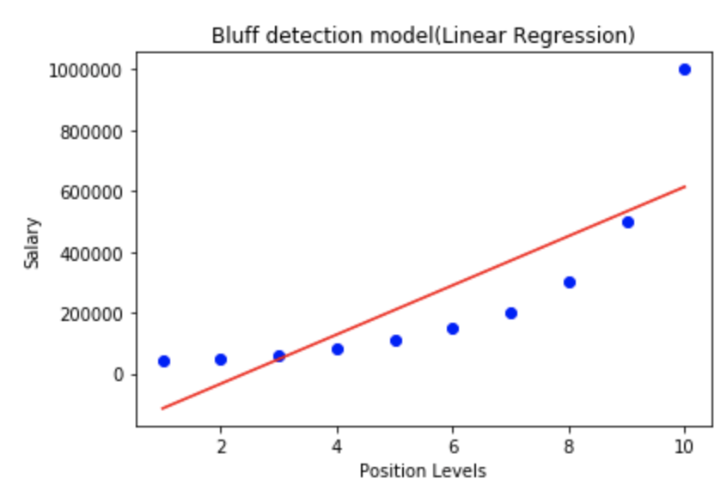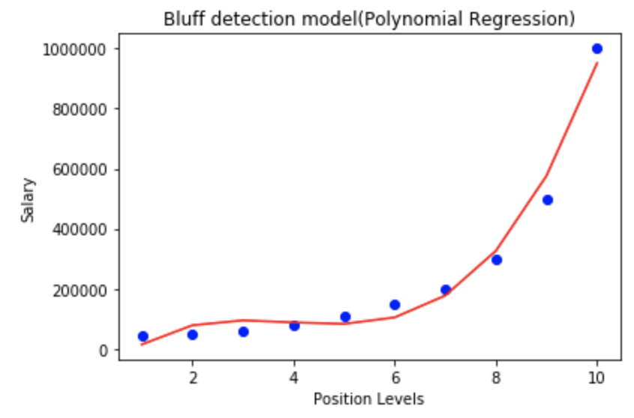

Disadvantages of Polynomial Regression
Polynomial regression may at a glance appear to be a perfect solution. However, note that polynomial regression:

- Is influenced by outliers and it may not handle them well.
- Cannot be validated as easily compared to linear regression.
- In most cases will lead to overfitting. Situations where it could be useful are rare.
- Becomes overly complicated when there is more than one predictor variable.

Due to the disadvantages mentioned, transformations with linear models are usually more common than polynomial models.

How Polynomial Linear Regression Works
Polynomial linear regression is a two-step process.

- A polynomial transformation is made for the predictor variable X. For example, for a polynomial degree of 4, if X=2 it is transformed into the following array:

[$x^{0}$, $x^{1}$,$x^{2}$,$x^{3}$,$x^{4}$] = [$2^{0}$, $2^{1}$,$2^{2}$,$2^{3}$,$2^{4}$] = [1, $2$,$4$,$8$,$16$]

- A linear regression model is fit with the transformed x values to generate the coefficients$b.$

In the end, the process generates equation:

y = $b_{0}$ $+$ $b_{1}x_{1}$ $+$ $b_{2}x_{1}^{2}$ $+$…$+$ $b_{n}x_{1}^{n}$

Figure 2 shows sample curves for differing polynomial degrees where the top two curves have degrees of 1 and 2 and the bottom curves have degrees 3 and 4.

Figure 2: Curve Shapes for Different Polynomial Degrees (Degrees from right to left starting at the top: 1,2,3,4)
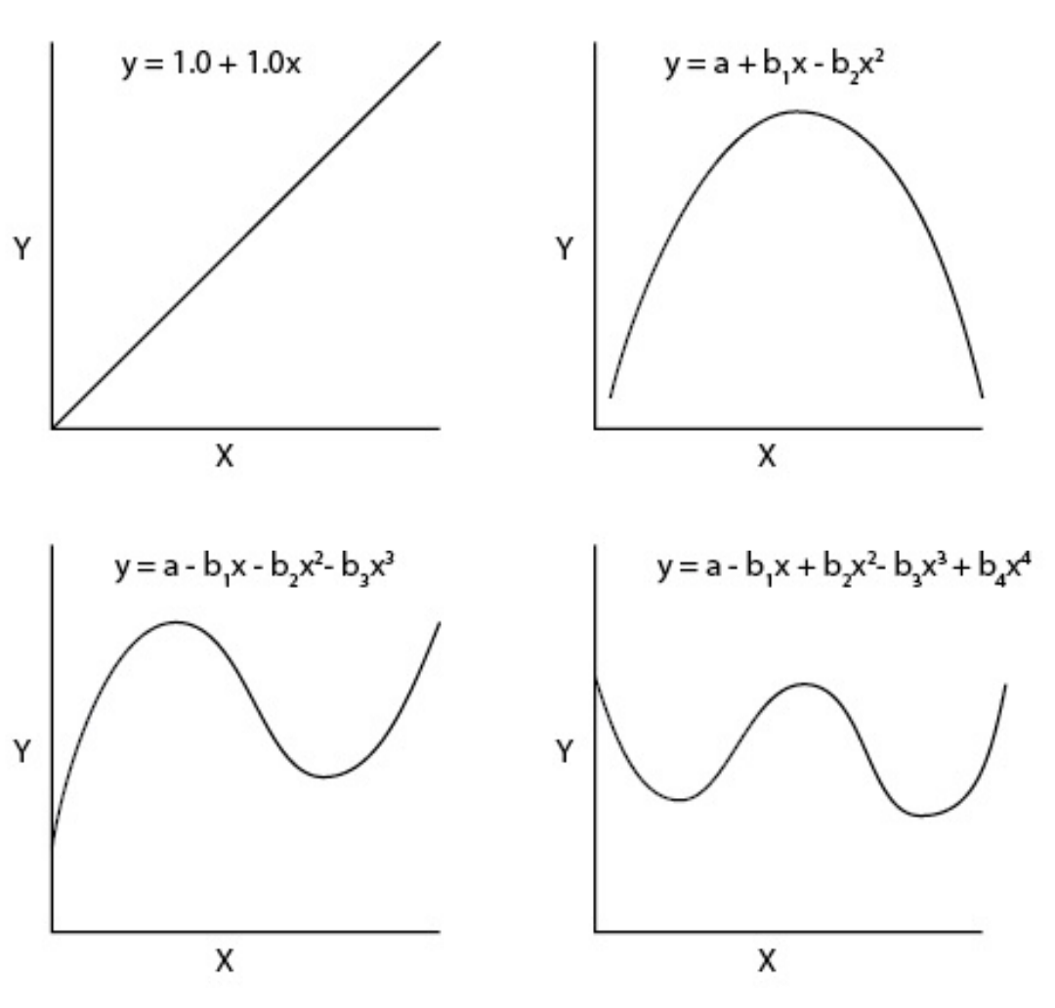
Reference: http://paleo.cortland.edu/class/stats/documents/15_PolyMultiRegression.pdf

Example 2: Polynomial Equations
This example is based on the example at https://www.javatpoint.com/machine-learning-polynomial-regression

This example takes the salary data on the left of Figure 3 and fits a line to it which is shown at the right of Figure 3.

Figure 3: Salary Level Data
Level (x) | Salary (y) | 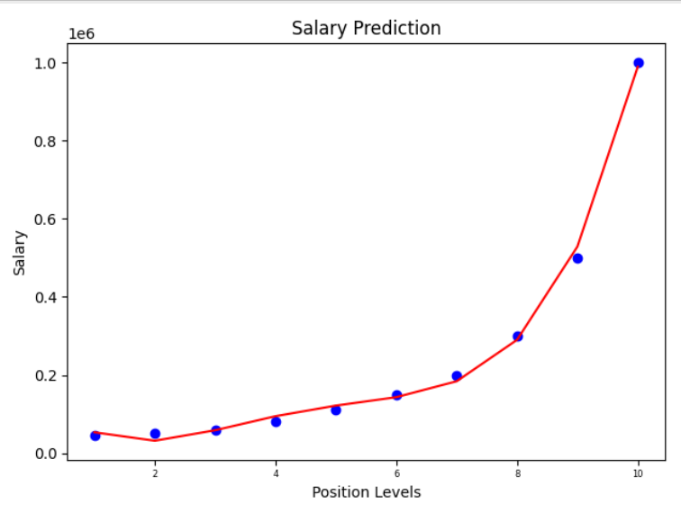
1 | 45000
2 | 50000
3 | 60000
4 | 80000
5 | 110000
6 | 150000
7 | 200000
8 | 300000
9 | 500000
10 | 1000000

For simplicity, this example uses all of the data to build the regression line. We will implement a proper train-test split later.
import pandas as pd
import matplotlib.pyplot as plt
from sklearn.linear_model import LinearRegression
from sklearn.preprocessing import PolynomialFeatures

# The data file path and file name need to be configured.
PATH = "/Users/pm/Desktop/DayDocs/PythonForDataAnalytics/workingData/"
CSV_DATA = "salaries.csv"

# Note this has a comma separator.
df = pd.read_csv(PATH + CSV_DATA)

# Extract target and salary.
x = df[['Level']]
y = df[['Salary']]

# Generate the matrix of x values which includes:
# x^0 (which equals 1), x^1, X^2, X^3 and X^4
polyFeatures = PolynomialFeatures(degree=4)
x_transformed = polyFeatures.fit_transform(x)

# Perform linear regression with the transformed data.
linReg = LinearRegression()
linReg.fit(x_transformed, y)

# Estimate dependent variable for polynomial equations.
predictions = linReg.predict(x_transformed)

# Visualize result for Polynomial Regression.
plt.scatter(x,y,color="blue")
plt.plot(x, predictions, color="red")
plt.title("Salary Prediction")
plt.xlabel("Position Levels")
plt.ylabel("Salary")
plt.show()

print(linReg.intercept_)
print(linReg.coef_)

Exercise 2 (4 marks)
Change the polynomial degree in Example 2 to 2. Show a screenshot of graph.
Change the polynomial degree in Example 2 to 3. Show a screenshot of graph.
Change the polynomial degree in Example 2 to 5. Show a screenshot of graph.

What can you conclude about the accuracy of the graph as you increase the polynomial degree?

Exercise 3 (2 marks)
When x=2 and the polynomial degree is 4, these two lines of code;

polyFeatures = PolynomialFeatures(degree=4)
x_transformed = polyFeatures.fit_transform(x)

transform x=2 into the array:

[$x^{0}$, $x^{1}$,$x^{2}$,$x^{3}$,$x^{4}$] = [$2^{0}$, $2^{1}$,$2^{2}$,$2^{3}$,$2^{4}$] = [1, $2$,$4$,$8$,$16$]

When x=3 and the polynomial degree is 4, what is the array that is generated by the polynomial transformation? Try to answer without running any code. You can then check your work by printing out the values of x_transformed.

Show the linear regression coefficients by running the instruction:

print(linReg.coef_)

Exercise 4 (2 marks)
Imagine that x=2 and the polynomial degree is 3. Without running any code, estimate the array output from the following PolynomialFeatures.fit_transform() function.

polyFeatures = PolynomialFeatures(degree=3)
x_transformed = polyFeatures.fit_transform(x)

Show the array here:

How many linear regression coefficients (b) are generated for this exercise? You can run the code to check your work.

Example 3: Implementing a Test–Train Split with Polynomial Regression
This example is similar to Example 2. However, the current example shows how to implement a test-train split function with the regression. Root mean square error is used to estimate the variance of the residuals even though the data set is actually too small to be practical.
import pandas as pd
from sklearn.linear_model import LinearRegression

# The data file path and file name need to be configured.
PATH = "/Users/pm/Desktop/DayDocs/PythonForDataAnalytics/workingData/"
CSV_DATA = "salaries.csv"

# Note this has a comma separator.
df = pd.read_csv(PATH + CSV_DATA)

# Extract target and salary.
X = df[['Level']]
y = df[['Salary']]

# Splitting the dataset into the Training set and Test set
from sklearn.model_selection import train_test_split
X_train, X_test, y_train, y_test = train_test_split(X, y,
test_size=0.2, random_state=0)

# Fitting Polynomial Regression to the dataset
from sklearn.preprocessing import PolynomialFeatures
poly_reg = PolynomialFeatures(degree=4)

# This line of code generates
# ['1', 'x0', 'x0^2', 'x0^3', 'x0^4']
# for all x values.
X_poly = poly_reg.fit_transform(X_train)

# Generate intercept and coefficient.
linReg = LinearRegression()
linReg.fit(X_poly, y_train)

print("\ncoefficients: ")
print(linReg.coef_)

print("\nIntercept: ")
print(linReg.intercept_)

poly_reg.fit_transform([[3]])

# Generate predictions.
# Predicting a new result with Polymonial Regression
predictions = linReg.predict(poly_reg.fit_transform(X_test))
print("\nPredictions")
print(predictions)

import numpy as np
RMSE = np.sqrt(np.sum((y_test - predictions)**2)/len(predictions))
print("RMSE: " + str(RMSE))

The RMSE is 38,573.73

Exercise 5 (1 mark)
To get a better understanding of how the PolynomialFeature() class works, use the following code:

# Fitting Polynomial Regression to the dataset
from sklearn.preprocessing import PolynomialFeatures
poly_reg = PolynomialFeatures(degree=4)

# This line of code generates
# ['1', 'x0', 'x0^2', 'x0^3', 'x0^4']
# for all x values.
X_poly = poly_reg.fit_transform([[2]])
print(X_poly)

The output is:
[[ 1. 2. 4. 8. 16.]]

Before actually running the code, guess what the output will be if you run:
X_poly = poly_reg.fit_transform([[4]])

Test your work and show what the output is:

Example 4: Generating Production Code
This example shows how to extract the model so you can generate production code. When you run the code, it generates a predicted value of $528,694.63 while the actual value is $500,000.

Table 1: Predicted Outcome
X_test | y_test | prediction
9 | 500,000 | 528,694.63

Add this code onto the end of Example 3 to manually implement your predictive model.
def productionModel(xarray, poly_reg):
# ['1', 'x0', 'x0^2', 'x0^3', 'x0^4']
# The polynomial tranform is an array the variable raised to
# different powers.
print("\nFeature Names: ")
print(poly_reg.get_feature_names())

# Show the polynomial features.
x = poly_reg.fit_transform(xarray)[0]

# Intercept from linear regression.
b = 135486.37366816

# Coefficients from linear regression.
b1 = -143427.12888394
b2 = 68157.93948411
b3 = -11608.84599445
b4 = 709.02332493

# Multiply linear regression coefficients by polynomial features.
predict = b * x[0] + b1 * x[1] + b2 * x[2] + b3 * x[3] + b4 * x[4]
print("\n***Prediction: " + str(predict))

Exercise 6 (2 marks)
Using the production code in Example 4, show the prediction output and corresponding y_test value when x=3.

Example 5: Practical Application of Polynomial Linear Regression
This example shows a more practical application of how to choose the polynomial degree for a polynomial linear regression model with the $R^{2}$ value. For this case, we are using the ‘lstat’ (lower status) predictor variable to predict ‘medv’ (medium value) of homes. The value of $R^{2}$ increases until a degree of 5 and then the returns diminish (see Figure 4).

Figure 4: Optimizing the Polynomial Degree
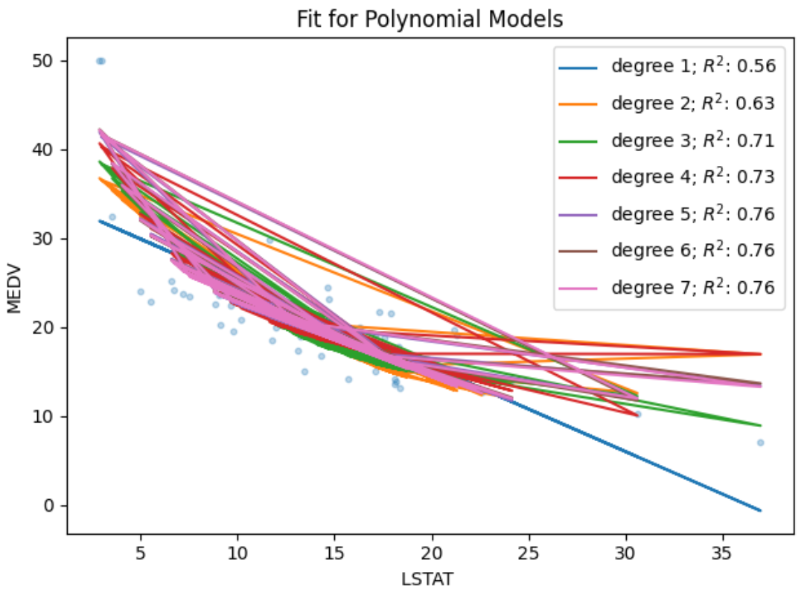
Here is the code:
import pandas as pd
import matplotlib.pyplot as plt
from sklearn.model_selection import train_test_split
from sklearn.preprocessing import PolynomialFeatures
from sklearn.linear_model import LinearRegression

PATH = "/Users/pm/Desktop/DayDocs/PythonForDataAnalytics/workingData/"
CSV_DATA = "usCityData.csv"
df = pd.read_csv(PATH + CSV_DATA)
X = df[['lstat']]
y = df[['medv']]

X_train, X_test, y_train, y_test = train_test_split(X,y,test_size=0.10, \
random_state=42, shuffle=True)

# Polynomial Regression-nth order
plt.scatter(X_test, y_test, s=10, alpha=0.3)

for degree in [1,2,3,4,5,6,7]:
# This line of code generates
# ['1', 'x0', 'x0^2', 'x0^3', 'x0^4']
# for all x values.
poly_reg = PolynomialFeatures(degree=degree)
transformed_x = poly_reg.fit_transform(X_train)

# Generate intercept and coefficient.
linReg = LinearRegression()
linReg.fit(transformed_x, y_train)

# Generate predictions and evaluate R^2.
transformed_x = poly_reg.fit_transform(X_test)
predictions = linReg.predict(transformed_x)
plt.plot(X_test, predictions, label="degree %d" % degree
+ '; $R^2$: %.2f' % linReg.score(transformed_x, y_test))

# Show the plots for all polynomial equations.
plt.legend(loc='upper right')
plt.xlabel("LSTAT ")
plt.ylabel("MEDV")
plt.title("Fit for Polynomial Models")
plt.show()

Exercise 7 (1 mark)
Don’t over think this question, I just want to make sure you don’t miss it. What polynomial degree should we select when examining the legend in Figure 4? Why?

Exercise 8 (6 marks)
Replot the data that is shown in Figure 4. However, this time show the RMSE for y_test and the prediction set in the labels that are displayed in the graph. Show a screenshot of the data here.

Show your code here:

Example 6: Displaying the Selected Polynomial Linear Regression Results
After selecting our degree of 5 for the polynomial function, this example shows how to graph a scatter of the test data and fitted prediction curve. To ensure the prediction line is drawn in an orderly sequence the X_test values are sorted before predictions are made.
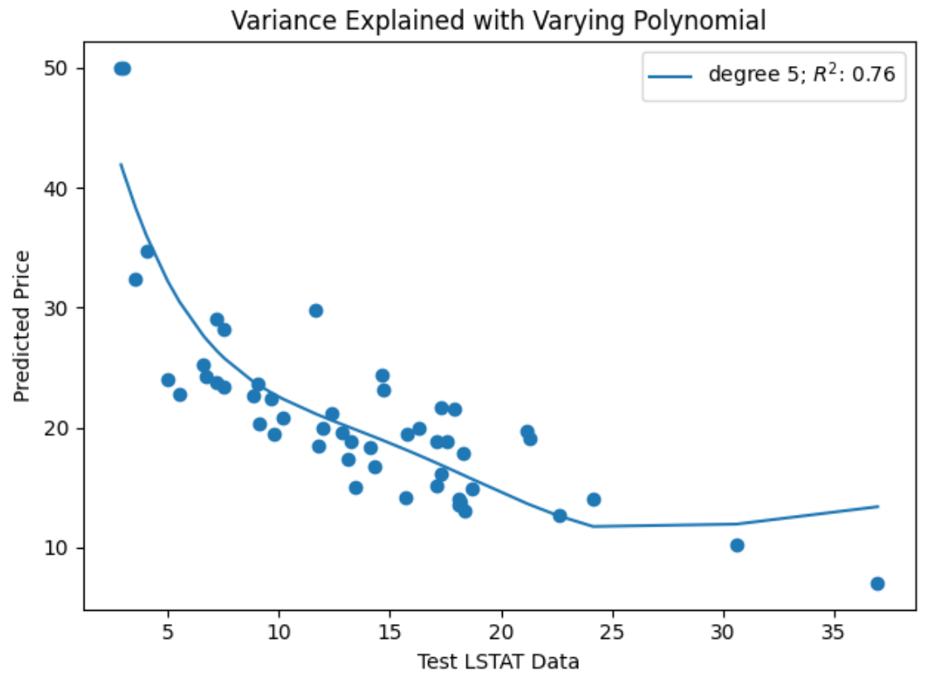
import pandas as pd
import matplotlib.pyplot as plt
from sklearn.model_selection import train_test_split
from sklearn.preprocessing import PolynomialFeatures
from sklearn.linear_model import LinearRegression

PATH = "/Users/pm/Desktop/DayDocs/PythonForDataAnalytics/workingData/"
CSV_DATA = "usCityData.csv"
df = pd.read_csv(PATH + CSV_DATA)
X = df[['lstat']]
y = df[['medv']]

X_train, X_test, y_train, y_test = train_test_split(X, y, test_size=0.10,
random_state=42,
shuffle=True)
# Draw scatter plot of the test set.
plt.scatter(X_test, y_test)

# Train the model.
degree = 5
poly_reg = PolynomialFeatures(degree=degree)
transformed_x = poly_reg.fit_transform(X_train)
linReg = LinearRegression()

# Generate linear regression model with transformed x.
linReg.fit(transformed_x, y_train)

# Sort the test data.
sortedTestDf = X_test[['lstat']]
sortedTestDf['medv'] = y_test[['medv']]
sortedTestDf = sortedTestDf.sort_values(['lstat'], ascending=[True])

# Generate predictions with sorted test data.
transformed_x_test = poly_reg.fit_transform(sortedTestDf[['lstat']])
predictions = linReg.predict(transformed_x_test)
print(predictions)

# Visualize the prediction line against the scatter plot.
plt.plot(sortedTestDf[['lstat']], predictions, label="degree %d" % degree
+ '; $R^2$: %.2f' % linReg.score(transformed_x_test, sortedTestDf['medv']))

plt.legend(loc='upper right')
plt.xlabel("Test LSTAT Data")
plt.ylabel("Predicted Price")
plt.title("Variance Explained with Varying Polynomial")
plt.show()

Exercise 9 (6 marks)
Generate the data production code from the model that is built in Example 6. See Example 4 for a hint on how to do this.

Exercise 10 (2 marks)
Using your data production code from Exercise 9, make a prediction for lstat = 2.88. (Hint: Notice how the double square brackets are used in Example 4 when making a prediction for x=9.) Show your output here:

Exercise 11 (3 marks)
Show the RMSE for the model that is built in Example 6.

Show the code that you added to Example 6 to generate the RMSE.

